Station 1:
Descriptive Writing Rubric and Self-Assessment

- Read through the NeSA Descriptive Writing Rubric in your packet.
- Highlight key terms in each column and row, paying special attention to key terms that help us identify the score for each domain.
- Your rubric should look like the example rubric at the table.
- At the bottom of your rubric, answer the following questions:
  - How does spending time looking at and working with the scoring rubric help you prepare for the test?
  - How can it make you a stronger writer?

- Locate the NeSa Writing Self-Assessment Tool
- This is a tool that is available for you to use on the writing test to help you think about your writing before you completely finish it. Using it as a resource to think about your own writing has the ability to make it stronger.
- Take some time to read through the Self-Assessment Tool.
- At the bottom of the Self-Assessment tool in your packet, answer the following question:
  - How can using the Self-Assessment tool on the NeSA Writing Test be beneficial to your writing? Why?

Station 2:
Anchor Papers
- Read through the Anchor Papers that are at the station.
  - Note: These are actual student responses to the state writing test in previous years.
  - Prompt: People gather at many places. This could be the cafeteria or gym at school, a park or sporting event, a room in your home, or any other place people get together. Choose one place you go where people gather. Think of the sights, sounds, feelings, smells, and/or tastes you experience there. Write an essay describing this place with sensory details so the reader can picture it and understand why you chose it.
- Using the rubric in your packet, score the paper how you think it should be scored.
- Mark your answers on the sheet in your packet.
- Compare your answers with everyone in your group. Try to get everyone to agree on the same scores.
- Ask one of the teachers for the actual scores on the papers and compare them to your own answers.
- Answer the following questions at the bottom of the score tracking sheet:
  - How close were your scores to the actual scores?
  - How can looking at other students’ writings and knowing how they were scored on the state test help you prepare for the writing test?

Station 3:
Show Me Sentences

- When using descriptive writing to jazz up our work, we need to make sure that we “show” instead of “tell”.

- For example, it is pretty easy for me to simply tell you that “My dog is lazy”. However, I think we can agree that it makes for a pretty boring sentence. Try this instead: “My dog likes to sleep on my bed. When I wake up in the morning, he growls when I turn on the light, and refuses to move when I try and make the bed. When I came home from work last week, I found him sprawled in the same place as I had left him, with his little doggie head resting on my pillow”.

- Do you see the difference? In the first example, I am simply telling you that my dog is lazy. In the second sentence, I am clearly showing you the lazy habits of my dog; I don’t need to specifically tell you that he is lazy, as it can be clearly inferred by the details in my writing.

- In the space in your packet, use the “Show and not Tell” strategy to make the sentences more exciting.

Station 5:
Showing and Telling Feelings
- When expressing feelings in writing, we could easily just write something like, “He was sad.” However, instead, we can make our writing more engaging and powerful by showing he was sad by describing what he was doing. We could write, “His head hung low as he sat in the chair. His shoulders shaking with sobs.” We can express so much more by showing.

- In each of the following boxes in your packet, create a list of vividly descriptive that can be used to express that feeling or emotion.

Station 6:
Showing and Telling Senses
- Often in our descriptive writing, we are asked to use sensory details to describe. For instance, for smell, we could use words like: perfumed, pungent, fresh, gaseous.

- On the “Showing and Telling Senses” page in your packet, create a list of at least 15 words that can be used to describe each sense. Use the word below to help get you started toward your fifteen words. Work together with your group to come up with your list.

- Some examples are listed below.
Sight | Sound | Smell | Taste | Touch
colorful  dark  dingy | loud  quiet  rumbly | perfumes  pungent  fresh | sour  sweet  bitter | soft  hard  gritty
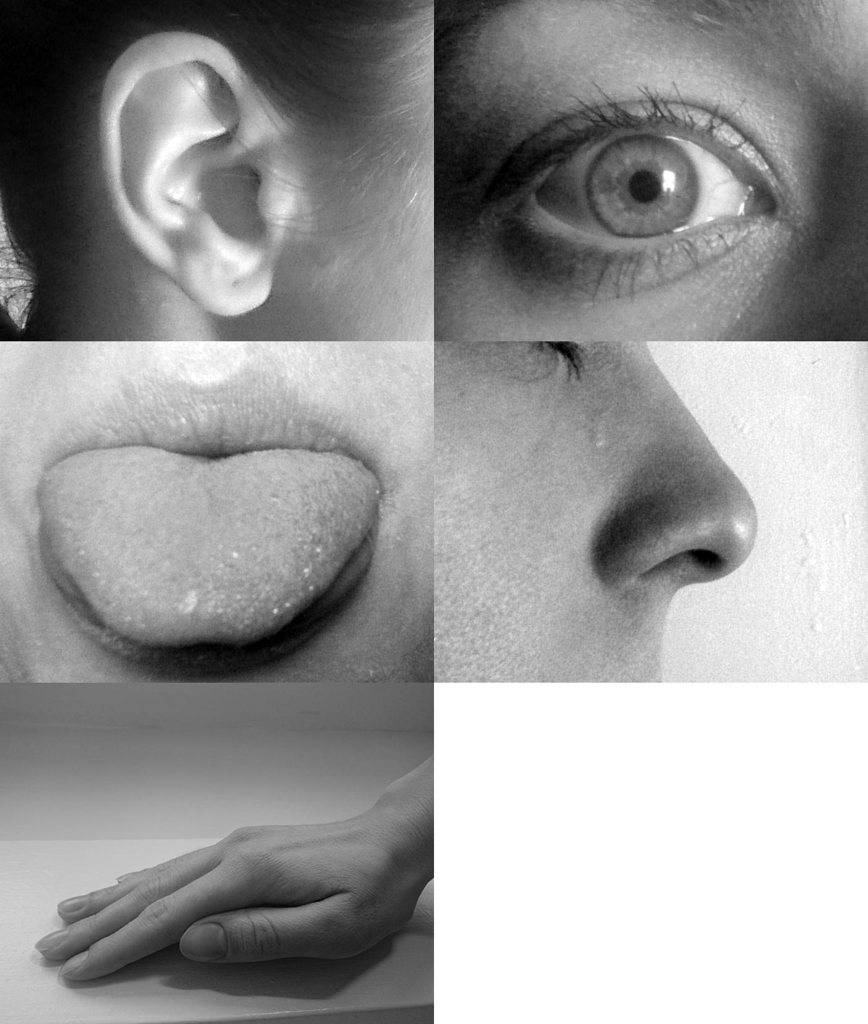
Station 4:
Show, Don’t Tell Kisses

- Grab one, and only one, chocolate kiss from the bag.
- Follow the directions from your packet and fill in the areas on the pages. Remember, don’t just tell what you see, smell, hear, taste, and feel, but show through your words.
- Each box should have more than just a few words. Instead, it should have enough information to provide a clear picture of each sense and your description of the chocolate kiss.
Note: You can’t use the word “chocolate” anywhere in your description!
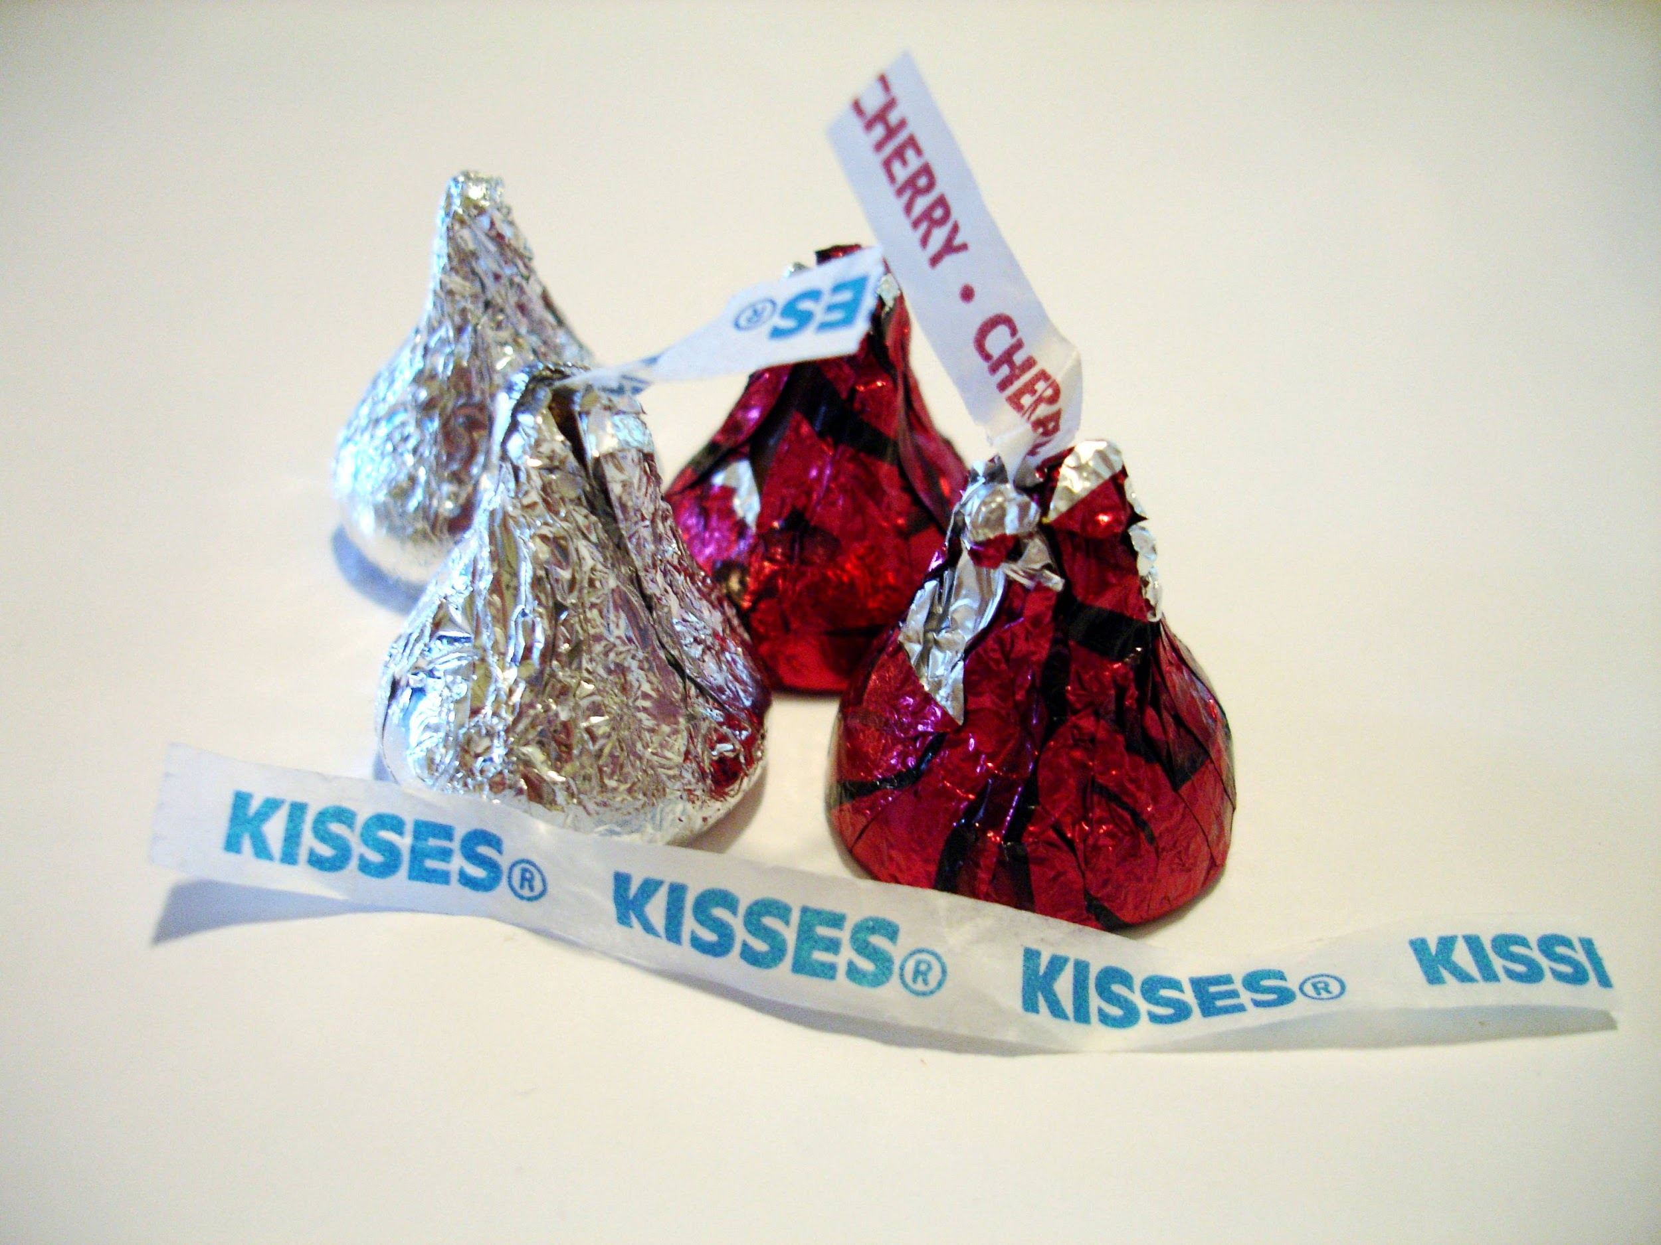
Station 7:
Showing and Telling Cookies
- Grab one, and only one, cookie from the bag.
- Follow the directions from your packet and fill in the areas on the pages. Remember, don’t just tell what you see, smell, hear, taste, and feel, but show through your words.
- Each box should have more than just a few words. Instead, it should have enough information to provide a clear picture of each sense and your description of the cookie.

Station 8:
Show, Don’t Tell
- Part 1: In each box you will find one “tell” sentence. This is not a very exciting sentence. In the space provided, write two sentences that you could use to “show” the same information. The first one is done for you.

- Part 2: Use the space provided to come up with your own show and tell sentences. Write the “tell” sentence in the small box. Write two “show” sentences in the space beside it.
  - Example (You can’t use this one! 😃):
She dragged herself into the bedroom and collapsed onto the bed.

She fought the urge to close her eyes and drift off to sleep.
She was very sleepy.

